POS Printing

# Project goals

1. POS printing to meet business requirements.
2. Define best practices for a codebase to ensure future-proof app development.
3. Ensure easy debugging for development and long-term maintenance.

# Project Scope

## Background

|  |  |  |
| --- | --- | --- |
| **No** | **Name** | **Description** |
| 1 | Print Queue Slow | 5 printers available   * Printers a, b, c wait for each other |
| 2 | Print Queue Overload | Too many print jobs in queue causes POS system to lag |
| 3 | Printer Not Responding (POS: 打印機沒有回應) | Users unaware which printer is unresponsive |
| 4 | Printer Missing Receipts (漏單) | Receipts not printed and no error reported |
| 5 | Network issue | The system cannot print receipts when there is no internet access  TODO: ask for more detail |
| 6 | Lack of Debugging Tools | No logs and monitoring for print jobs, printers, or device status   * Makes debugging difficult for developers |

## Features and Functionality

1. Receipt Generation and Printing
2. Data Source Integration
3. Printer Integration and Connectivity
4. Printing Queue Management
5. User Interface
6. Customization and Template
7. Error Handling and Reliability
8. Logging and Monitoring
9. Security and Compliance
10. Scalability and Maintenance

## Deliverables

1. **POS Printing Application**: Optimized for high-volume F&B receipts, featuring scalable, future-proof capabilities.
2. **Codebase Best Practices**: Structured and documented codebase adhering to industry standards, ensuring scalability, maintainability, and ease of future extensions.

# Requirements

## Functional Requirements

Receipt Generation and Printing

* generate receipts containing order details
* support printing receipts on current **Printer List**
* support printing of barcodes, QR codes and images
* support receipt printing in multiple languages
* support multiple printers to print receipts simultaneously **(issue1)**
* support fallback printer **(enh5)**
* support printer assignment (tag) **(enh2)**

Data Source Integration

* support order polling (online)
* support local network order (offline) **(issue5)**

Printer Integration and Connectivity

* support current printers
* support ethernet connection
* support usb connection
* support auto-detect connected printers and configure settings for immediate use

Printing Queue Management **(enh3)**

* support list view for printing queue **(issue4) (enh1,3)**
* support kill job(s)
* support resume job(s)
* support pause job(s)

User Interface

* support printer connectivity IP setting
* support printer connectivity MAC address setting **(enh4)**
* support OmniWe **GQL:ShopDevice.configs**
* TBC...

Customization and Template

* support OmniWe API **GQL:ShopReceiptTemplate**

Error Handling and Reliability **(issue3, 4)**

* queue print jobs during network or printer downtime and process them once connectivity is restored
* display alerts for printer issues, such as paper out, printer offline
* automatically retry failed print jobs up to three times before notifying the user

Logging and Monitoring **(issue6)**

* log all print activities, including successes and failures, for troubleshooting
* TBC: push metrics (printer health, hardware health, ...etc)

Security and Compliance

* require user authentication (e.g., username/password or OAuth) to access print functions and settings
* maintain an audit trail of changes to receipt templates, printer settings, and user access.

Scalability and Maintenance

* handle high transaction volumes, supporting at least **1000** simultaneous print jobs per store **(issue2)**
* provide automatic software updates to support new printer models and features (code push)
* TBC: remote monitoring tools for administrators to check printer and application status.remote monitoring tools for administrators to check printer and application status.
* TBC: expose an API for integration with third-party systems, such as inventory or CRM software.

## Non-Functional Requirements

|  |  |
| --- | --- |
| **Name** | **Description** |
| Printing queue batch size | Min: 1000 message per second  Max: 5000 message per second |
| Printing Response time | TBC: Min: ?? ms -> action ->  use case -> to -> print (total: time)   * F&B mobile order : order polling <= 5s * Local network: <= 1s |

## User Requirements (Enhancement)

|  |  |  |
| --- | --- | --- |
| **No** | **Name** | **Description** |
| 1 | Print Tracking | able to identify which order was printed |
| 2 | Printer Assignment | able to specify which printer handles specific receipt |
| 3 | Printer Stuck | able to reprint  able to view print queue  able to test printer  able to restart when printer jams |
| 4 | MAC Address Recognition | able to use MAC address recognition in settings |
| 5 | Fallback Printer | able to assign a fallback printer for when a printer fails |

## System Requirements

|  |
| --- |
| **Description** |
| **OS:** > Android 9  **RAM:** 4GB  **Storage:** 64GB  **Screen size:** TBC.. may confirm Jacky current supported screen size |

# System Architecture

## Architecture Overview

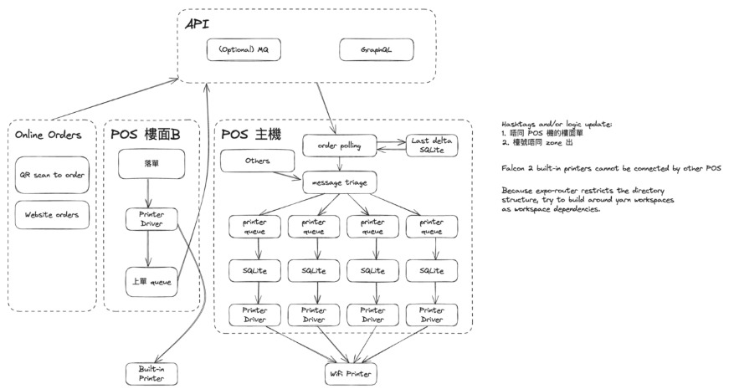

## Technology Stack

|  |  |
| --- | --- |
| **Name** | **Description** |
| Frontend | * React Native * Expo |
| Database | * SQLite |
| Printer Integration | * TODO... |
| API Ingrgration | * GraphQL: TODO... * Rest API: TODO... |
| Security | JWT?  Security Store? |
| State Management | * React Context API |
| Styling | NativeWind ? TODO...  Styled Components? TODO... |
| Logging and Monitoring | Sentry ? TODO... |
| Development and Build Tools | * Expo CLI * TypeScript * ESLint + Prettier * e2e test?? TODO... |
| DevOps and Deployment | * Expo EAS (Expo Application Services) * Gitlab CI/CD |

## Design

TODO....

# Development Plan

## To-dos list

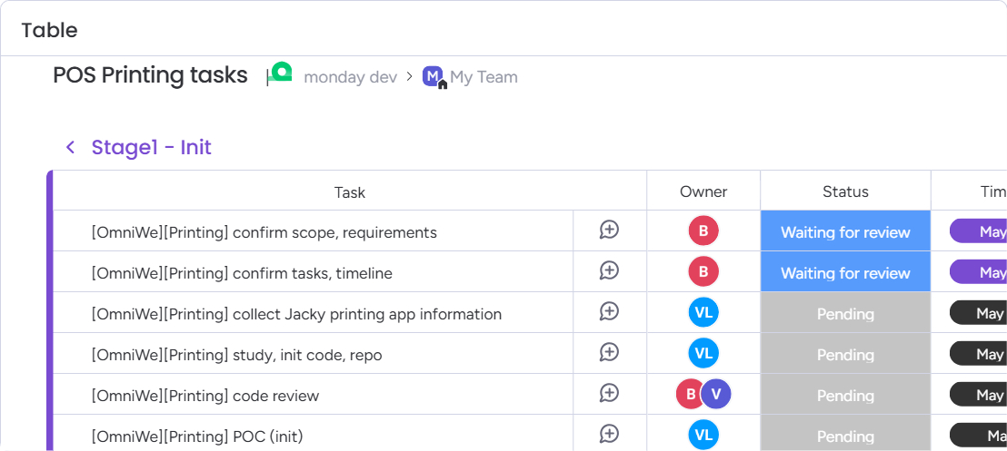

## To-dos Gantt

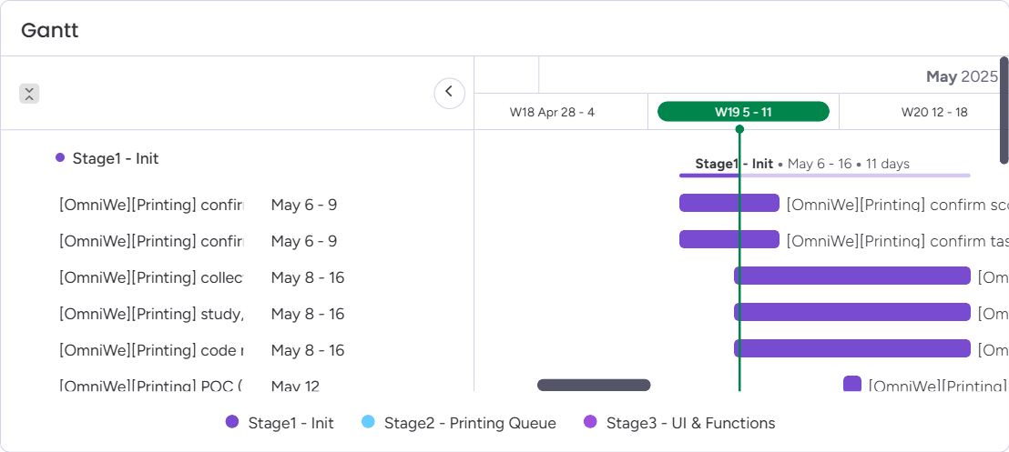

# Testing Plan

TODO....

# Deployment Plan

TODO....

# Risk Management

TODO....

# Team and Roles

|  |  |
| --- | --- |
| **Person** | **Role** |
| [Vicary](https://august-solutions.monday.com/users/37109462) [SuperWebster](https://august-solutions.monday.com/users/37372756) [Joseph Cheung](https://august-solutions.monday.com/users/61451575) | Project Owner |
| [Billy](https://august-solutions.monday.com/users/37109756) | Project ??, Developer |
| [Victor Law](https://august-solutions.monday.com/users/74482044) | Developer |

# References

### POS List

|  |  |
| --- | --- |
| **Name** | **Model No** |
| Imin | Falcon1, Falcon2 |
| Xiaomi | TBC... |
| Honor | TBC... |

### Printer List

|  |  |
| --- | --- |
| **Name** | **Model** **No** |
| Epson | tm-t82x (lan version) |
| Citizen | ct-d150 (usb / lan version) |
| Citizen | cl-e321 (usb / lan version) |
| Xprinter | XP-N160II |
| Star | TSP100 |

### Receipt Samples

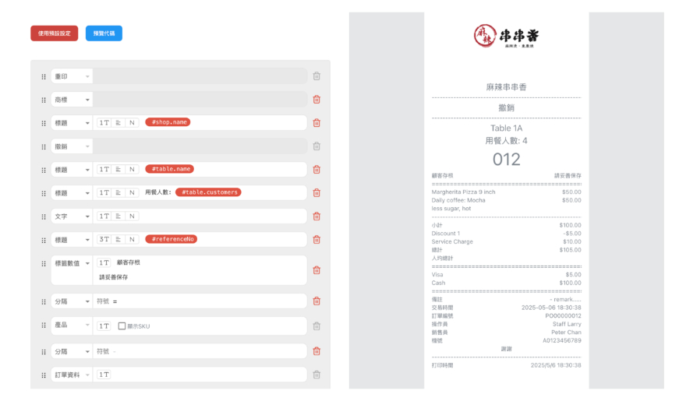

### Printing Architecture Draft

<https://excalidraw.com/#room=66fd7ca45dd4b8b1b7d5,eKYcmnEQdlbMl6mufDK3vA>